ASSIGNMENT 2(A)

//Zombie State

#include <stdio.h>
#include <sys/types.h>
#include <sys/wait.h>
#include <stdlib.h>
#include <unistd.h>

//bubble sort
void bubbleSort(int array[], int size)
{
for (int step = 0; step < size - 1; ++step)
{
for (int i = 0; i < size - step - 1; ++i)
{
if (array[i] > array[i + 1])
{
int temp = array[i];
array[i] = array[i + 1];
array[i + 1] = temp;
}
}
}
}

void printArray_bubble(int array[], int size)
{
for (int i = 0; i < size; ++i)
{
printf("%d ", array[i]);
}
}

//quick sort
void swap(int *a, int *b) {
int t = *a;
*a = *b;
*b = t;
}

int partition(int array[], int low, int high) {

int pivot = array[high];
int i = (low - 1);

for (int j = low; j < high; j++) {
if (array[j] <= pivot) {

i++;
swap(&array[i], &array[j]);
}
}
swap(&array[i + 1], &array[high]);
return (i + 1);
}

void quickSort(int array[], int low, int high) {
if (low < high) {
int pi = partition(array, low, high);
quickSort(array, low, pi - 1);
quickSort(array, pi + 1, high);
}
}

void printArray_quick(int array[], int size) {
for (int i = 0; i < size; ++i) {
printf("%d ", array[i]);
}
printf("\n");
}

void main()
{
int data[] = {8,5,7,6,3};
int size = sizeof(data) / sizeof(data[0]);
int pid, status;

pid = fork();

if(pid==0)
{

printf("\n Welcome to child process");
printf("\n Child process id %d \n",getpid());
printf("\n Child's parent process id %d \n",getppid());

printf("\n Unsorted Array : ");
printArray_quick(data, size);
bubbleSort(data, size);

printf(" Bubble Sort :: Sorted Array in Ascending Order : ");
printArray_bubble(data, size);
printf("\n\n");
}
else if(pid!=0)
{
printf("\n");
sleep(5);
system("ps -aux");
printf("\n Welcome to Parent process");
printf("\n parent process id %d \n",getpid());

printf("\n Unsorted Array : ");
printArray_quick(data, size);
quickSort(data, 0, size - 1);

printf(" Quick sort :: Sorted array in ascending order : ");
printArray_quick(data, size);
}
}
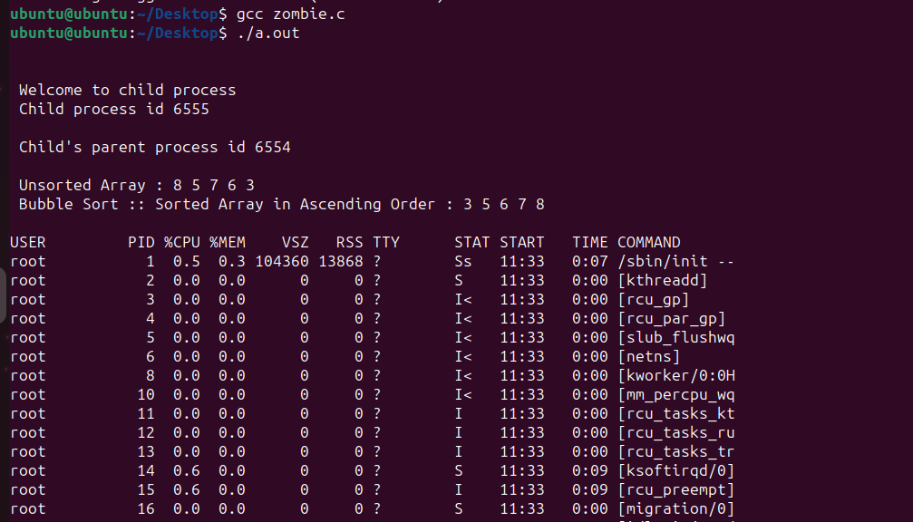
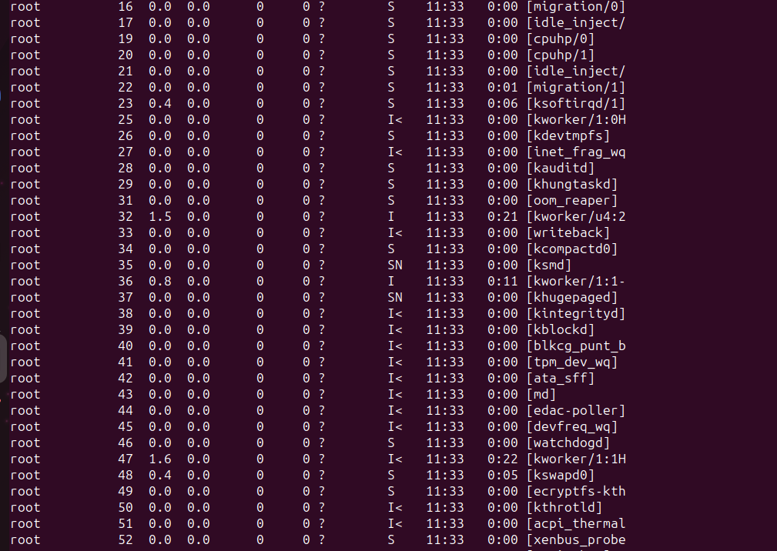

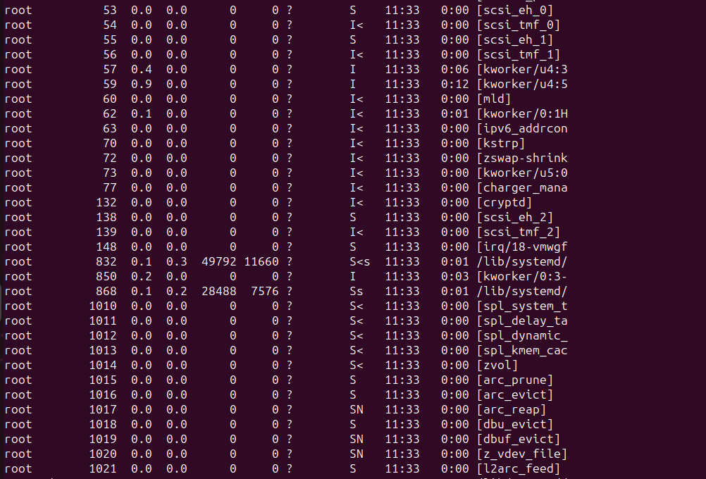
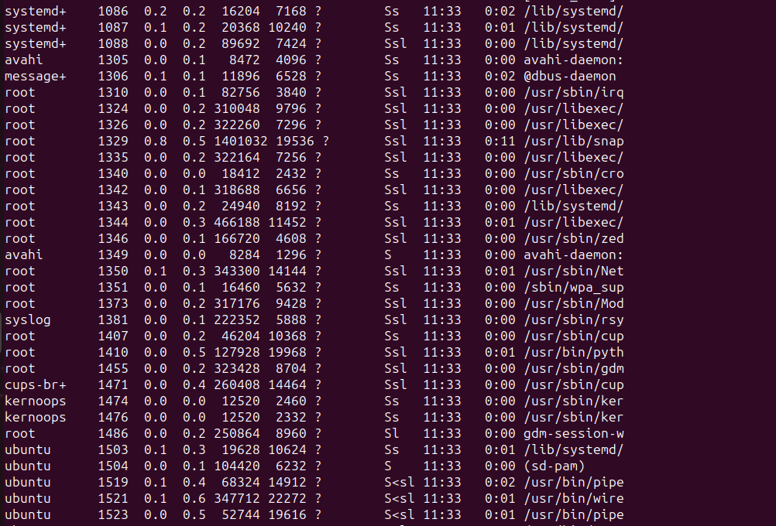
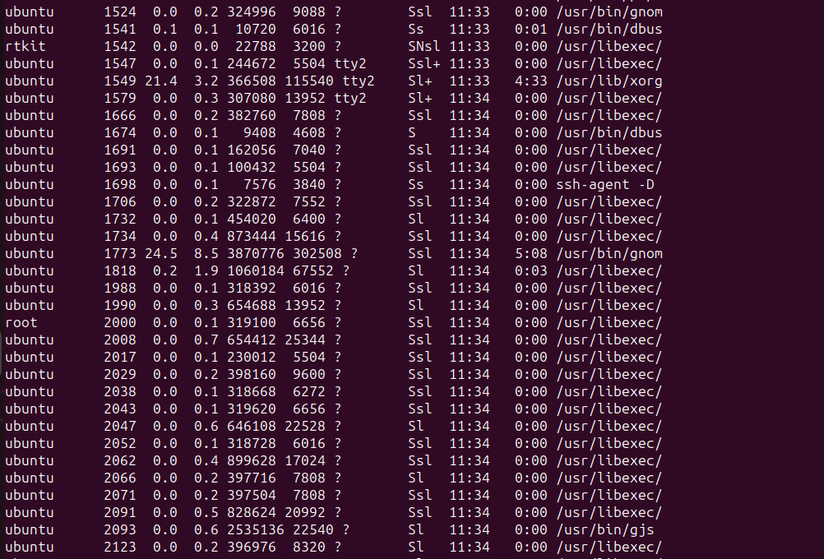
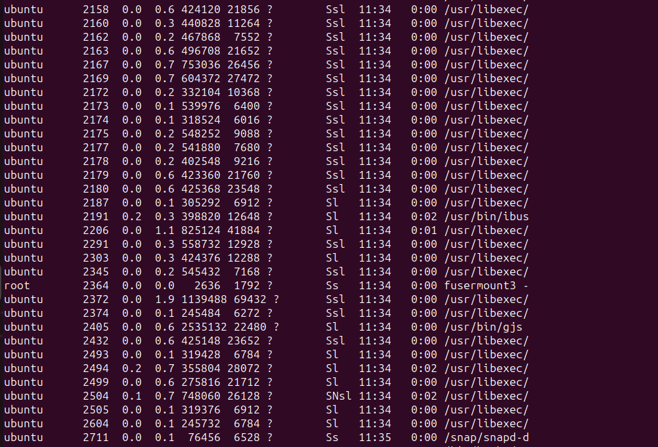
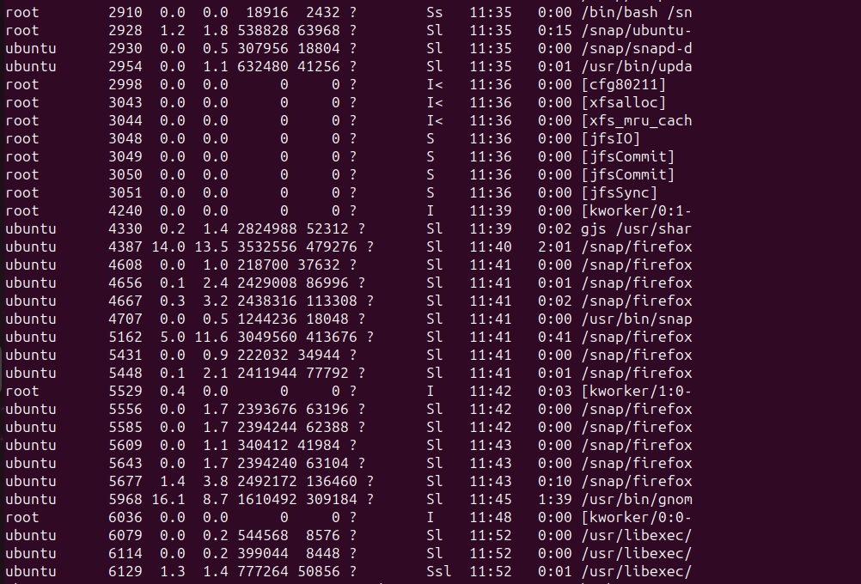
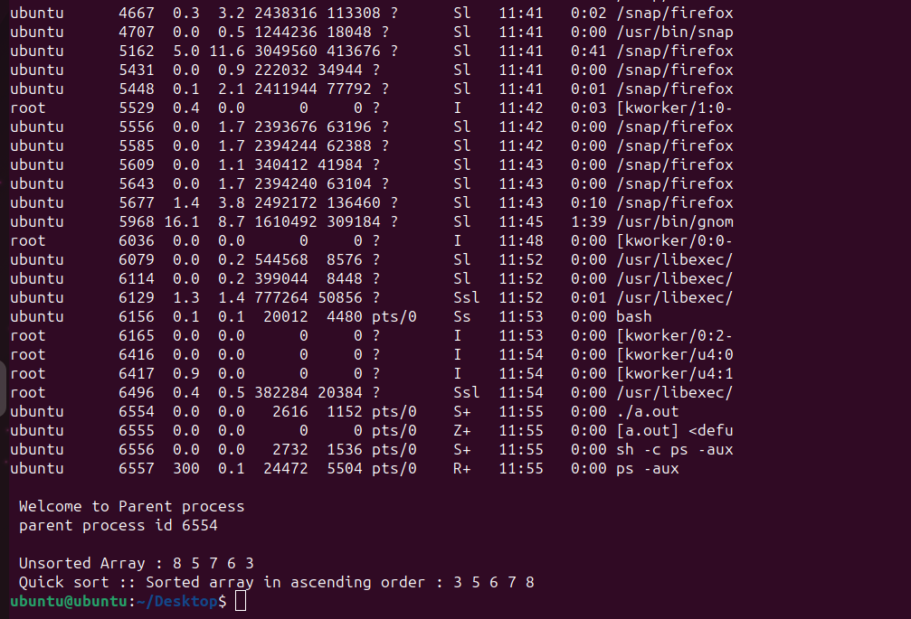

//ORPHAN STATE

#include <stdio.h>
#include <sys/types.h>
#include <sys/wait.h>
#include <stdlib.h>
#include <unistd.h>

// bubble sort
void bubbleSort(int array[], int size)
{
for (int step = 0; step < size - 1; ++step)
{
for (int i = 0; i < size - step - 1; ++i)
{
if (array[i] > array[i + 1])
{
int temp = array[i];
array[i] = array[i + 1];
array[i + 1] = temp;
}
}
}
}

void printArray_bubble(int array[], int size)
{
for (int i = 0; i < size; ++i)
{
printf("%d ", array[i]);
}
}

// quick sort
void swap(int *a, int *b)
{
int t = *a;
*a = *b;
*b = t;
}

int partition(int array[], int low, int high)
{
int pivot = array[high];
int i = (low - 1);
for (int j = low; j < high; j++)
{
if (array[j] <= pivot)
{

i++;
swap(&array[i], &array[j]);
}
}
swap(&array[i + 1], &array[high]);
return (i + 1);
}

void quickSort(int array[], int low, int high)
{
if (low < high)
{
int pi = partition(array, low, high);
quickSort(array, low, pi - 1);
quickSort(array, pi + 1, high);
}
}

void printArray_quick(int array[], int size)
{
for (int i = 0; i < size; ++i)
{
printf("%d ", array[i]);
}
printf("\n");
}

void main()
{

int data[] = {8, 5, 7, 6, 3};
int size = sizeof(data) / sizeof(data[0]);
int pid, status;
pid = fork();

if (pid == 0)
{
printf("\n Child's parent process id %d \n", getppid());
sleep(3);
printf("\n Welcome to child process \n");
printf("\n Child process id %d \n", getpid());
printf("\n Child's parent process id %d \n", getppid());

printf("\n Unsorted Array : ");
printArray_quick(data, size);
bubbleSort(data, size);

printf(" Bubble Sort :: Sorted Array in Ascending Order : ");
printArray_bubble(data, size);
printf("\n\n");
}
else if (pid != 0)
{

printf("\n Welcome to Parent process \n");
printf("\n parent process id %d \n", getpid());

printf("\n Unsorted Array : ");
printArray_quick(data, size);
quickSort(data, 0, size - 1);

printf(" Quick sort :: Sorted array in ascending order : ");
printArray_quick(data, size);
}
}

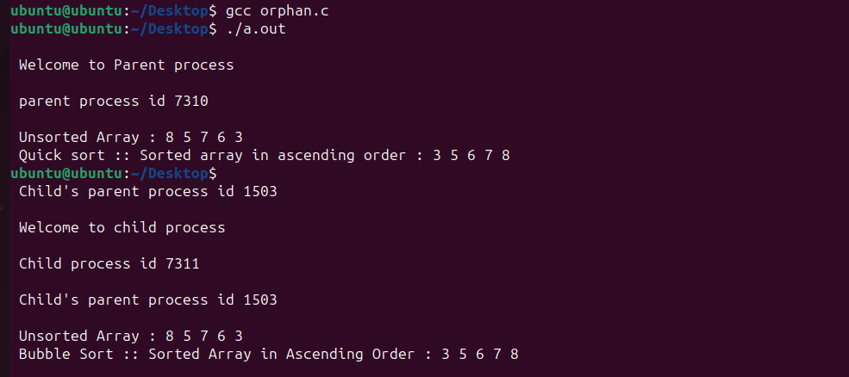

//Wait demo on Zombie state

#include <stdio.h>
#include <sys/types.h>
#include <sys/wait.h>
#include <stdlib.h>
#include <unistd.h>

// bubble sort
void bubbleSort(int array[], int size)
{
for (int step = 0; step < size - 1; ++step)
{
for (int i = 0; i < size - step - 1; ++i)
{
if (array[i] > array[i + 1])
{
int temp = array[i];
array[i] = array[i + 1];
array[i + 1] = temp;
}
}
}
}

void printArray_bubble(int array[], int size)
{
for (int i = 0; i < size; ++i)
{
printf("%d ", array[i]);
}
}

// quick sort
void swap(int *a, int *b)
{
int t = *a;
*a = *b;
*b = t;
}

int partition(int array[], int low, int high)
{

int pivot = array[high];
int i = (low - 1);

for (int j = low; j < high; j++)
{
if (array[j] <= pivot)
{

i++;
swap(&array[i], &array[j]);
}
}
swap(&array[i + 1], &array[high]);
return (i + 1);
}

void quickSort(int array[], int low, int high)
{
if (low < high)
{
int pi = partition(array, low, high);
quickSort(array, low, pi - 1);
quickSort(array, pi + 1, high);
}
}

void printArray_quick(int array[], int size)
{
for (int i = 0; i < size; ++i)
{
printf("%d ", array[i]);
}
printf("\n");
}

int main()
{
int data[] = {8, 5, 7, 6, 3};
int size = sizeof(data) / sizeof(data[0]);

int pid, status;
pid_t w1;
pid = fork();

if (pid == 0)
{

printf("\n Welcome to child process");
printf("\n Child process id %d \n", getpid());
printf("\n Child's parent process id %d \n", getppid());

printf("\n Unsorted Array : ");
printArray_quick(data, size);
bubbleSort(data, size);

printf(" Bubble Sort :: Sorted Array in Ascending Order : ");
printArray_bubble(data, size);
printf("\n\n");
}
else if (pid != 0)
{
w1 = wait(&status);
printf("\n Status is %d \n", WEXITSTATUS(status));
printf(" Return value of wait,w1=%d \n", w1);

printf("\n");
sleep(5);
system("ps -aux");
printf("\n Welcome to Parent process");
printf("\n parent process id %d \n", getpid());

printf("\n Unsorted Array : ");
printArray_quick(data, size);
quickSort(data, 0, size - 1);

printf(" Quick sort :: Sorted array in ascending order : ");
printArray_quick(data, size);
}
}

